**Experiment - 11**

AIM ::

Create a Basic Calculator App using JS.

Code :

**index.html**

<!DOCTYPE html>

<html lang="en">

<head>

<meta charset="UTF-8" />

<meta name="viewport" content="width=device-width, initial-scale=1" />

<link href="https://cdn.jsdelivr.net/npm/bootstrap@5.3.0/dist/css/bootstrap.min.css" rel="stylesheet" />

<link rel="stylesheet" href="style.css" />

<title>Basic Calc</title>

</head>

<body>

<div class="container mt-5">

<h1 class="text-center mb-4">Simple Calculator</h1>

<div class="calculator bg-light p-3">

<div class="display" id="Text-Field">

<span class="result" id="Result-Part"></span>

<span class="expression" id="Expr-Part"></span>

</div>

<div class="row g-2">

<div class="col-3">

<button class="btn btn-light btn-custom" onclick="ClearText()">

AC

</button>

</div>

<div class="col-3">

<button class="btn btn-light btn-custom" onclick="ClearLastCharacter()">

⇐

</button>

</div>

<div class="col-3">

<button class="btn btn-light btn-custom" onclick="SquareValue()">

x<sup>2</sup>

</button>

</div>

<div class="col-3">

<button class="btn btn-light btn-custom" onclick="AddNumber('/')">

/

</button>

</div>

<div class="col-3">

<button class="btn btn-light btn-custom" onclick="AddNumber(7)">

7

</button>

</div>

<div class="col-3">

<button class="btn btn-light btn-custom" onclick="AddNumber(8)">

8

</button>

</div>

<div class="col-3">

<button class="btn btn-light btn-custom" onclick="AddNumber(9)">

9

</button>

</div>

<div class="col-3">

<button class="btn btn-light btn-custom" onclick="AddNumber('*')">

*

</button>

</div>

<div class="col-3">

<button class="btn btn-light btn-custom" onclick="AddNumber(4)">

4

</button>

</div>

<div class="col-3">

<button class="btn btn-light btn-custom" onclick="AddNumber(5)">

5

</button>

</div>

<div class="col-3">

<button class="btn btn-light btn-custom" onclick="AddNumber(6)">

6

</button>

</div>

<div class="col-3">

<button class="btn btn-light btn-custom" onclick="AddNumber('-')">

-

</button>

</div>

<div class="col-3">

<button class="btn btn-light btn-custom" onclick="AddNumber(1)">

1

</button>

</div>

<div class="col-3">

<button class="btn btn-light btn-custom" onclick="AddNumber(2)">

2

</button>

</div>

<div class="col-3">

<button class="btn btn-light btn-custom" onclick="AddNumber(3)">

3

</button>

</div>

<div class="col-3">

<button class="btn btn-light btn-custom" onclick="AddNumber('+')">

+

</button>

</div>

<div class="col-3">

<button class="btn btn-light btn-custom" onclick="AddNumber(0)">

0

</button>

</div>

<div class="col-3">

<button class="btn btn-light btn-custom" onclick="AddNumber('00')">

00

</button>

</div>

<div class="col-3">

<button class="btn btn-light btn-custom" onclick="AddNumber('.')">

.

</button>

</div>

<div class="col-3">

<button class="btn btn-primary btn-custom" onclick="Evaluate()">

=

</button>

</div>

</div>

</div>

</div>

<script src="script.js"></script>

<script src="https://cdn.jsdelivr.net/npm/bootstrap@5.3.0/dist/js/bootstrap.bundle.min.js"></script>

</body>

</html>

**style.css**

body {

background-color: #f2f4f8;

font-family: 'Segoe UI', Tahoma, Geneva, Verdana, sans-serif;

}

.calculator {

max-width: 350px;

margin: auto;

background-color: #ffffff;

padding: 20px;

border-radius: 20px;

box-shadow: 0 10px 25px rgba(0, 0, 0, 0.1);

}

.display {

height: 60px;

background-color: #f1f3f4;

color: #000;

font-size: 22px;

font-weight: bold;

padding: 10px 15px;

border: none;

border-radius: 10px;

text-align: left;

display: flex;

justify-content: space-between;

align-items: center;

}

.display .result {

color: #000;

font-weight: bold;

}

.display .expression {

color: #888;

font-size: 18px;

}

.btn-custom {

width: 100%;

height: 60px;

font-size: 22px;

font-weight: bold;

border-radius: 12px;

transition: background-color 0.2s ease;

}

.btn-custom:hover {

background-color: #dcdcdc;

}

.btn-primary.btn-custom {

background-color: #0d6efd;

color: #fff;

border: none;

}

.btn-primary.btn-custom:hover {

background-color: #0b5ed7;

}

**script.js**

let expression = "";

function AddNumber ( value )

{

expression += value;

UpdateDisplay();

}

function ClearText ()

{

expression = "";

UpdateDisplay();

}

function ClearLastCharacter ()

{

expression = expression.slice( 0, -1 );

UpdateDisplay();

}

function SquareValue ()

{

try

{

const squared = Math.pow( eval( expression ), 2 );

expression = squared.toString();

UpdateDisplay();

} catch

{

expression = "";

UpdateDisplay( "Error" );

}

}

function Evaluate ()

{

try

{

const result = eval( expression );

UpdateDisplay( result );

expression = result.toString(); // to continue calculations

} catch

{

UpdateDisplay( "Error" );

expression = "";

}

}

function UpdateDisplay ( result = "" )

{

const resultSpan = document.getElementById( "Result-Part" );

const exprSpan = document.getElementById( "Expr-Part" );

resultSpan.textContent = result !== "" ? result : "";

exprSpan.textContent = expression;

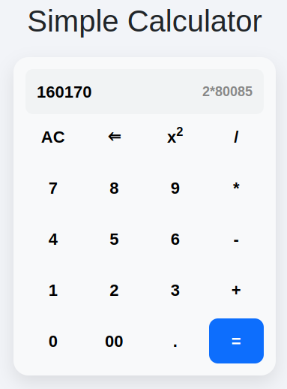}

Output ::